// Program to create array of subjects in 3rd semester.....

#include<iostream>

using namespace std;

int main() {

char \*subjects[7]={"Discrete Structures","Data Communication","DSA","Cloud Comp.","App. Dev.","Unix & Shell Modelling","Web Dev."};

for (int i=0;i<7;i++)

cout<<subjects[i]<<"\n";

return 0;

}

Output:

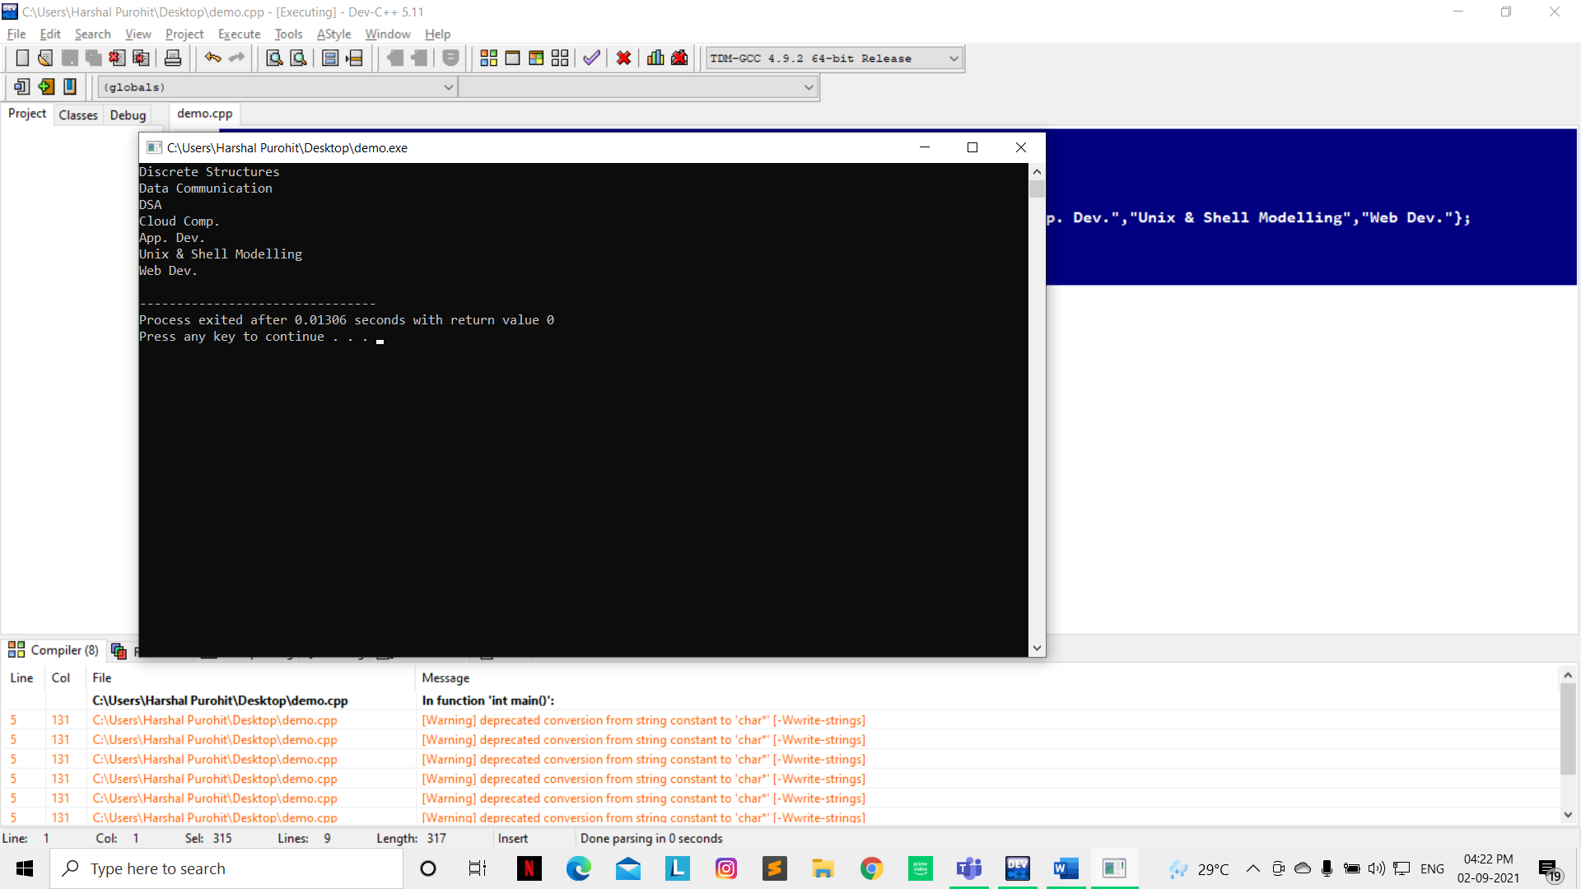

// Program to create 10 element array & print it reverse.....

#include<iostream>

using namespace std;

int main() {

int arr[10]={1,2,3,4,5,6,7,8,9,10};

for (int i=9;i>=0;i--)

cout<<arr[i]<<"\n";

return 0;

}

